Parent Handbook
Table of Contents
P.224Q Sites 3
P.224Q School Hours 4
Arrival and Dismissal 4
Attendance 5
Student Information 5
Medical Issues 6
Medication 7
Trips 8
Meetings 8
Communication with Staff 9
Dress Code 10
Academics 10
Homework 11
Textbooks/Technology Devices 12
Breakfast and Lunch Eligibility 12
Bussing 12
Code of Conduct / Items Prohibited in School 14
Consequences (K-8) 15
Use of Cell Phones 15
Internet 18
CONTRACT for Cell Phone, Computing Device, Portable Music and Entertainment Systems 19

P.224Q Sites

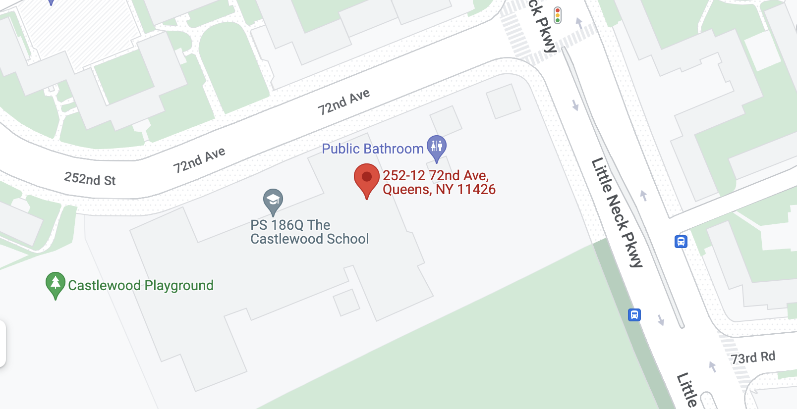
Main Site: 186Q Pre K-5th
252-12 72nd Avenue 11426
(718) 831-4024

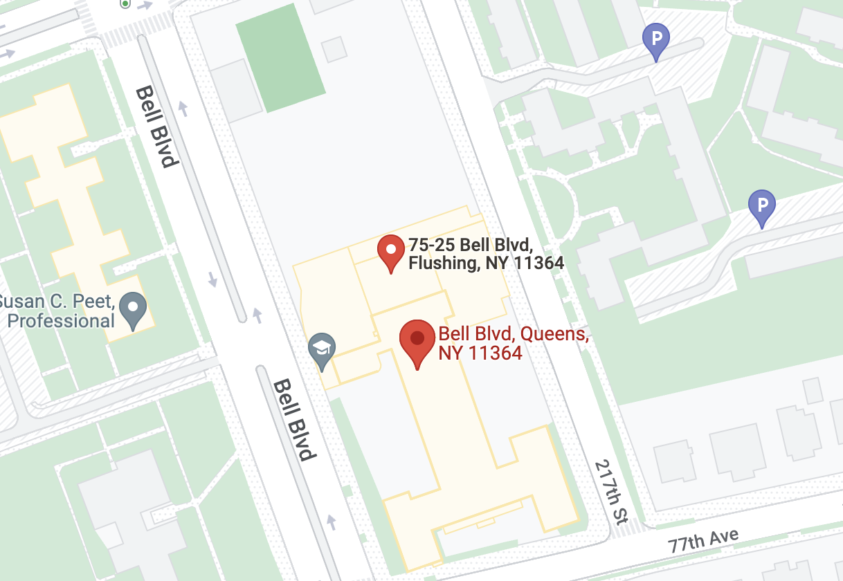
205Q K-5th
75-25 Bell Boulavard 11364
(718) 464-5776

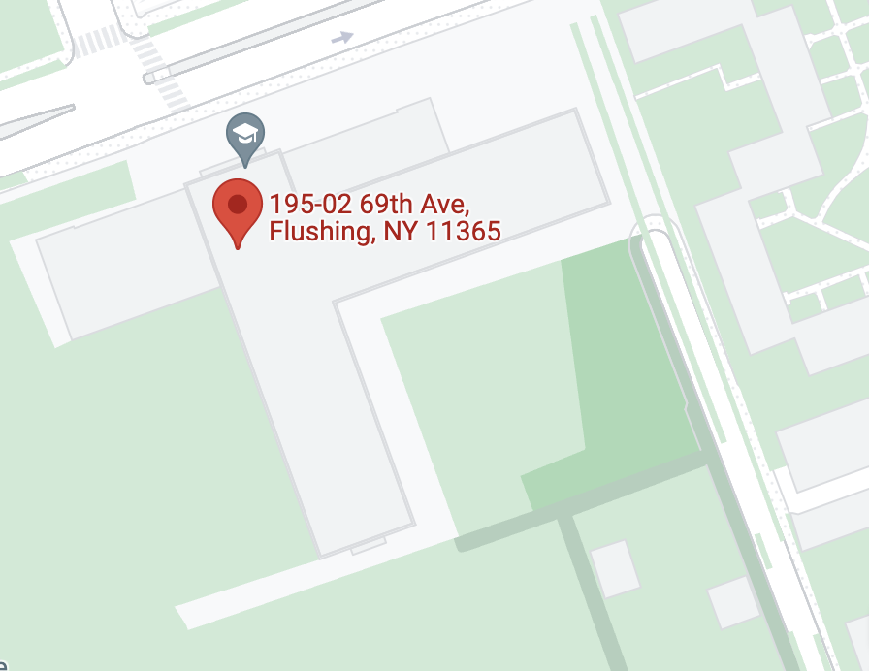
026Q K-3rd
195-02 69th Avenue 11365
(718) 464-4369
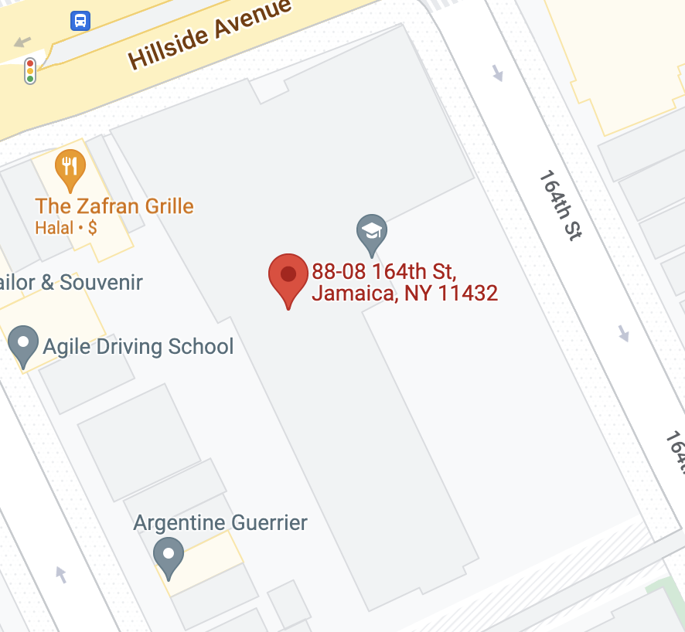
314Q K-8th
88-08 164th Street 11432
(718) 558-6227

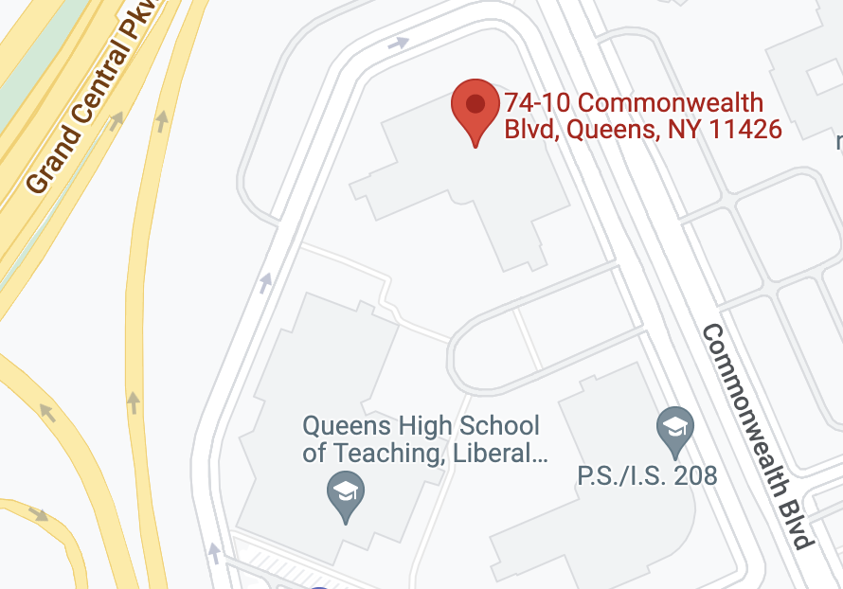
266Q 6th-8th Grade:
74-10 Commonwealth Boulavard 11426
(718) 479-4322

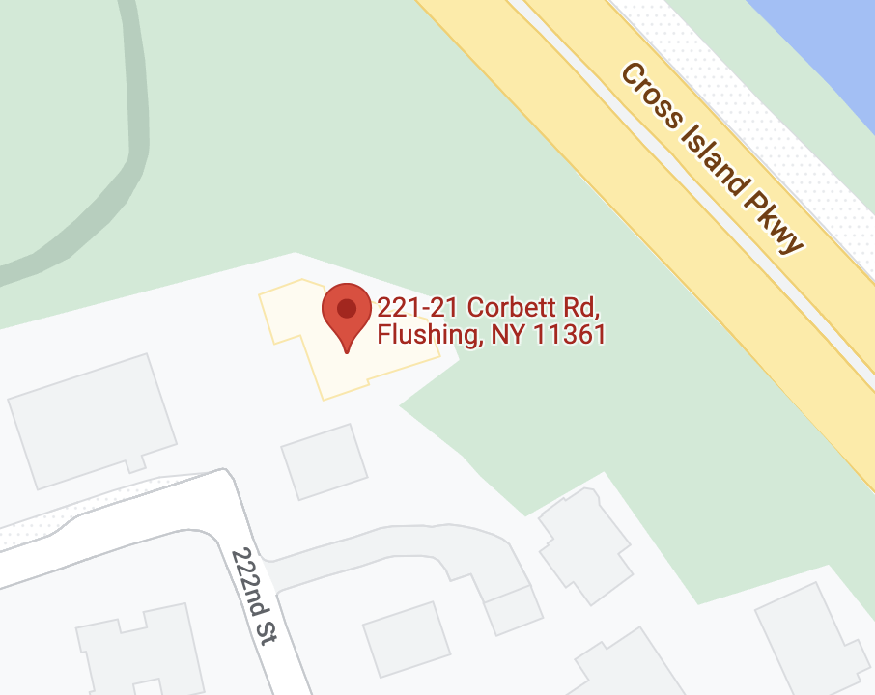
710Q Pre K:
221-21 Corbett Road 11361
(718) 225-8667

P.224Q School Hours

K-8 P.224Q all sites Monday-Friday 8:00 AM - 2:20 PM
PreK P.224Q@710/186 Monday-Friday 8:20 AM - 2:20 PM

Arrival and Dismissal
- Most students travel to school by school bus.
- Parents bringing their children to school, must sign their child in out in the P.224Q arrival and departure book. Please confirm with office staff the location of the sign out book.
- After being signed in by the parent/guardian, a staff member will come to get your child and escort him/her to class.
- Any student brought in by a parent after 8:00 AM will be marked late.
- For safety and security reasons, no parents may go directly to the classrooms. All parents must sign in at security and proceed to the Unit Coordinator’s office when visiting their child’s site.
- If you plan to pick up your child from school or send someone else to do so, please send a note in your child’s back pack informing us of these details. Remember this person must be on the blue card on file at the school and must have photo identification. You can call the site prior to lunchtime to ensure this information has been received, however, for the safety of all children, these requests must be in writing. (See sample on last page which can be duplicated and used)

Attendance
- Students are expected to attend school every day.
- 95% attendance is recommended by the Chancellor. Good attendance has a high correlation to student success.
- Parents must call the school when a student is absent to inform us of the reason. If we do not hear from you in the morning, the school will contact your home.
- A written note must accompany the child upon his or her return to school as required by education law. A doctor’s note can excuse a student from an unauthorized absence.
- An attendance teacher will be notified if a student is absent for three or more days and we are unable to contact the parent. In addition, after three days you will need to contact the bus company to reinstate pick up.
- If a student is going out of town for an extended period of time, we must have the following information in writing: where the student is going, how long they will be away, a phone number and address where contact can be made even if it is out of the country.
- Parents receive a monthly attendance chart indicating their child’s total current absences. This is to help you meet their individual attendance goal and be aware of any attendance issues/patterns

Student Information
During 2022-2023 school year, we are changing our procedures for gathering student information from paper to an online platform using a website called, "Operoo." "Operoo" provides a simple way to sign forms and share emergency/medical data with the school. "Operoo" is available in a variety of languages. More information will follow with instructions.
Anytime information changes (i.e. a change of address, telephone number, etc.) please contact the school immediately. (It is good practice to share change of numbers with the bus company as well.)

Medical Issues
- There is a school nurse available at every site.
- If a student has a medical problem, the nurse will call the home to inform the parent of the nature of the condition and what necessary steps should be taken.
- If there is a life-threatening emergency, EMS will be called while contact with a parent is being established. A parent must go to the hospital as soon as possible to meet their child.
- If a student comes to school with visible cuts, scars, or bruises you must call the school before the child arrives or send a letter to the school informing us as to how the child received the injury. Likewise, if a staff member observes a cut or bruise on a child while at school, the child will be brought to the nurse. The nurse will then call to inform you of the injury and any details available.
While good attendance is always encouraged, please do not send a sick child to school. For the sake of good health for all students and staff, we ask for your cooperation in this matter. If the nurse determines that a child is too sick to remain in school, you will be called to pick them up in a timely fashion. Please note the nurse’s decision is based on medical training and established DOE protocols.
Understand that certain conditions (i.e. fever, allergic reaction, etc.) will require an immediate parent pick up. A child with such conditions is not able to be put on a school bus so please plan accordingly.
** Please be sure you have listed names and working phone numbers of 3 emergency contacts who can pick up your child &/or be reached in an emergency if you are not available.

Medication
- Never send students to school with over-the-counter medication to self-administer (i.e. Tylenol etc.)
- In order for the nurse to give medication to a student, a signed consent form must be received from the doctor which indicates the type and dosage of medication to be given. The Medication Administration Form is valid through the end of summer school. It must be renewed before school starts each September and must accompany the student the first day the child attends.
- Every time a doctor makes a change to the schedule of medication distribution, type, or dosage, a new form must be signed by the doctor before changes can be made by the nurse.
- Medication must be brought to school in the original bottle with the correct information on the label.
- Some students take medication at home only. On any day that a child did not receive that medication at home, the parent must call the school to inform us, as behavior during school hours may greatly be affected due to the absence of that medication. If this situation occurs, we will ask that someone bring the medication to school as soon as possible.
- It is advisable to leave a bottle of medication in school with a permission form from a doctor. That will enable the nurse to administer the medication if the student did not receive it at home on any particular day.
- Feel free to contact the nurse at any time with questions or medical concerns
- Any student who has an allergy must have medical documentation on file with the nurse. This must be updated every year.

Trips
- Educational trips are scheduled at different times throughout the school year to coincide with your child’s classroom activities and curriculum.
- A signed permission slip must be sent back to school three days prior to the scheduled trip.
- Some children have health services that require some form of individual treatment by a licensed nurse (i.e. assisting a child in using an inhaler for asthma). During the school day, our onsite nurse is available for any/all treatments. On class trips, these students must have a nurse available for them during the entire trip.
- We do request a trip nurse for all trips with a student requiring nursing services. This nurse accompanies the class/students and can administer any necessary treatments. Occasionally, the DOE cannot provide a nurse. We will make every attempt to call you if we know there will be no trip nurse available from the DOE. Often we do not know this until 9:30 am on the day of the trip.
- If time permits, you (or a designated family member with a letter of permission from you) may come to school to accompany your child on the trip.

Meetings
There are Parent/Teacher Conference meetings and times set aside each school year for parents to meet with teachers. Please be aware that OTs and PTs are not mandated to attend evening conferences but are available during the afternoon conferences. Additionally, you may schedule in-person or phone conferences throughout the school year between 2:20 and 2:50pm. At least once a year a meeting must be scheduled with your IEP or SBS team to review your child’s progress and develop next year’s IEP. When the annual review of the IEP is scheduled, your attendance will be requested. You will be sent notices of these meetings in advance.
If you would like to arrange any other meetings, you can schedule these in writing or by phone with your child’s classroom teacher or Unit Coordinator.
Unscheduled visits are impossible to accommodate since we need sufficient notice to provide coverage for staff to meet with you.

Communication with Staff
P. 224Q has a website that is used as a primary way of communicating with parents. While the website does not yet eliminate “backpacked flyers” and other information at this time, it is a preferred and convenient mode. Please visit our website at p224q.site. P.224Q currently uses the REMIND system to send out important information. Operoo is used for forms and Instagram/Facebook for calendar events and updates. Please ensure you are signed up to receive messages.
To schedule a meeting with an administrator, please call or email them directly. Administrators may be at various sites or district meetings, but will coordinate a meeting day/time convenient for you.
Outside of the yearly scheduled meetings, if you need to see a teacher, you must make an appointment to see them. You may send a note or call the school and ask the secretary or Parent Coordinator to have the teacher call you back. The teacher will schedule an appointment. Appointments are limited in time (approximately 40 minutes), as a teacher will be meeting with you during his/her preparation period and a teacher will need to return to class to teach after seeing you. However, accommodations can be made in the event of a serious or pressing concern that is not resolved in that time frame.
Teachers cannot receive phone calls during class time. If you need to speak to a teacher you can send in a note or leave a message and the teacher will return your call as soon as possible.
Please check your child’s book-bag every day. Often we send home letters and information with your child that require timely follow-up.
A classroom communication log or point sheet goes home with each student every day telling you how/what your child did in school that day.
The communication log or sheet provides a section where parents and teachers can make comments. This is an important means of communication between home and school.
If, when your child arrives home, you do not receive a communication log or sheet, please call the school the next morning.

Dress Code
- Please check that your child is dressed appropriately before they leave the house each day.
- T-shirts should not display messages that are inappropriate or violent.
- Students should dress in clothing that is not provocative.
- Hats, sweatbands, “doo rags” and bandanas are not permitted to be worn in the building.
- Please be sure your child wears sneakers on gym days, as these are the only shoes permitted during gym class.

Academics
P. 224Q is comprised of students classified as students who take Standardized Assessments (SA) or students who do not participate in standardized assessements and are assessed alternately (AA).
Our curricula for Standard Assessment students is aligned to the Learning Standards (LS) - the same as in General Education. However, much of the material is modified and presented to the students in a way to meet their individual needs
Students in Grades 3 - 8, in the Standardized Assessment (SA) testing category take all New York State tests and local assessments, with any modifications that are stipulated on the student’s IEP.
Students who are in the Alternate Assessment (AA) testing category follow a modified curriculum connected to LS at their functional level. These students in Grades 3 - 8, participate in New York State Alternate Assessments (NYSAA).
We send the NYS Testing calendar home at the beginning of each year and post it on our website. It is also posted on the DOE main website.
Students in Pre-K - Grade 2 do not take State tests, but are assessed by other school and City assessments that measure growth in Literacy and Mathematics.

Homework
- Homework is given every day (Fridays are optional). If a teacher decides not to give homework, it will be indicated in the "Comments"section of the communication log or point sheet.
- Homework is generally a review of concepts/skills that have already been taught
- The amount of homework given is based on a student’s age, functional ability and grade level
- Homework must be done every day unless you send in a note.

Textbooks/Technology Devices
- Students are responsible for all textbooks and technology devices given to them. If your child loses or damages a textbook or device you will be asked to pay for the item.

Breakfast and Lunch Eligibility
- All children are entitled to free breakfast and lunch.
- If you choose to send in your child’s lunch, please be sure it is prepared and ready to eat. Children’s lunch boxes are stored on classroom shelves or cubbies. Food Service Kitchen Aides are not permitted to store or heat children’s own lunches. Some parents use a thermos or insulated containers to keep foods hot or cold. Teachers do not have access to microwaves or refrigerators to heat or cool food.

Bussing
- Bus Service is provided by the Department of Education / Office of Pupil Transportation (OPT). The Office of Pupil Transportation will upload your child’s bus information into your NYC MYSCHOOLS account. It will include the bus route and the company information.
- If the information is not in your child's MYSCHOOLS account or if you have any questions you can call OPT (718-392-8855 or 718-784-3313) and ask them for the information. Be sure to have your child’s OSIS ID number on hand.
- PM drops can be requested through OPT with the forms on their website. Please inform your child’s site when you have requested that OPT initiate a PM drop for your child.
- At morning pick up, an adult waits curbside with their child until the bus arrives. The matron escorts children onto the bus and to their seats. Parents are not permitted on school buses. An adult must be curbside in the afternoon to receive their child.
- At afternoon drop off, the matron will escort the child off and can only release children to the responsible adult at curbside.
- If your child’s IEP indicates the service of a bus paraprofessional, he or she will meet you at the bus when it arrives. Paras are not permitted to wait alone with your child at pick up or drop off times.
- A bus para’s job is to ensure a child’s safety while the bus transports the child to and from school. If your child has this service, OPT will not permit him or her to ride the bus without the bus para being present. In the event they are unable to ride, the Para will make every attempt to secure a substitute. However, there are times this may not be possible. The guardian is then responsible for bringing their child to and from school using an alternate mode of transportation.
- For all bussing issues, the quickest way to get information about your child’s bus or location is by calling OPT or using links to specific bussing concerns at https://www.p224q.site/bussing-information
- Bus companies are very difficult to reach by phone during high volume hours. OPT updates information in real time as they receive it from bus companies. If you are filing a complaint, always record the complaint number they give you.
Please Contact OPT @ 718-784-3313 or 718-392-8855 and the school if :
- You need to know your child’s bus#
- You have issues with the bus arriving too early or late in the AM or PM
- You have issues with the driver or matron
- You need to know the location of your child’s bus
- There is a problem with the air conditioning on the bus
- There are behavior/safety issues on the bus
The bus companies are contracted through the DOE, and OPT supervises bus personnel. School administration does not supervise the drivers and matrons. The school will attempt to assist you with busing issues; however, you should follow the protocol of calling the bus and OPT first. Be sure to document when and with whom you speak and include the complaint number if applicable.

Code of Conduct / Items Prohibited in School
Every classroom teacher has rules that students need to follow in order to create a safe learning environment. These rules are posted in the front of each classroom. Some rules may vary from class to class depending on the teacher, grade level, the functioning and behavioral levels of the students. The following rules are school-wide and all students will be held accountable for these rules:
- Students will stay in the room and building.
- No student is allowed to leave the room or building without permission.
- Students will respect all other students and adults.
- Fighting, teasing, bullying, cyberbullying or any act of violence will not be tolerated.
- Students will respect school property and the property of other students and adults.
- Defacing or damaging school property including bulletin boards and other student work will carry serious consequences.
- Students will work toward reaching their full potential.
- The role of the student is to follow the course of classwork and homework established by the classroom teacher.
- Students will not bring prohibited items to school. They include any sharp or dangerous items and toys. If you are not sure if an item belongs in school, please leave it home. Forbidden items may only be returned to a parent during a school visit.

Consequences (K-8)
Consequences for not adhering to school rules may include: not earning points; phone call to parent; meeting with parent; guidance meeting; Principal suspension (in school); Superintendent’s suspension (out of school). (See NYCDOE Citywide Standards).
Severe incidents such as student to student or student to teacher violence or sexual harassment may be reported to the police and dealt with legally.
P. 224Q follows the Citywide Standards of Intervention and Discipline Measures (The Discipline code and student Bill of Rights and Responsibilities, K-12) as well as the Social Media Guidelines: 12 and Younger. These are sent home each year and are available on DOE Website.
Use of Cell Phones
Our experience with students bringing cell phones and entertainment systems to school has been that too often they go missing (lost or stolen) either in school or on the bus. This creates many issues regarding questioning students and investigating incidents. We feel it is the safest policy for students not to have them in school. As our sites are small, everyone has the ability to make and receive calls to their parents in an emergency. We also feel it can lead to miscommunication if students are being communicated with directly and administration and/or staff is not also informed. However, should a parent wish to have their child carry a cell phone, a contract must be signed before doing so. The contract will be sent home at the beginning of the year to applicable students or through parent request anytime throughout the year. Information about devices in school is contained on the next few pages. A copy of the contract you are required to sign is on page 19.

P. 224Q Policy for use of Cell Phones, Computing Devices, and Portable Music and Entertainment Systems on School Property

*Adopted by School Leadership Team: February 27, 2015
As per the Chancellor’s Regulation A-413 students are permitted to bring the following items to school as of March 2nd 2015. 1) cell phones; 2) laptops, tablets, and other similar computing devices; and 3) portable music and entertainment systems, such as iPods, MP3 players, PSP, and Nintendo DS. However, the school has the ability to set their own policy with guidelines from Regulation A-413 on using these devices in school.
If you choose to send your child to school with an electronic device please review and sign the attached contract with your child so that he/she is clear on the expectations set forth in the P224 Cellphone, Computing Devices and Entertainment Policy adopted from Chancellor’s Regulation A-413
NO CELLPHONE OR ELECTRONIC DEVICE IS ALLOWED IN SCHOOL WITHOUT A SIGNED CONTRACT.
A. Cell phones
During the school day:
Cell phones may not be turned on or used while on school property.
Cell phones may not be turned on or used during instructional time.
B. Computing Devices
Computing devices may not be turned on or used while on school property. They can be used only if and as indicated on a student’s I.E.P.
C. Portable music and entertainment systems may be used as set forth below
During the school day:
Portable music devices and entertainment systems may not be turned on or used while on school property.
D. Confiscation and return of electronic items for violation of the rules above
- First offense: confiscation of item and returned at end of school day. Letter to parent informing them of violation of the rule and consequence if it occurs again.
- Second offense: confiscation of item and returned to parent following an "in school" parent conference.
- Third offense: confiscation of item, item returned to parent and revocation of privilege to bring item to school.
If student refuses to hand over a device as set forth above , the parent must come to school the next day with the student for a meeting. Student may be subject to disciplinary action as set forth in The DOE’s Discipline Code such as In- School or Principal Suspension
E. Discipline for violation of the rules below
The use of cell phones, computing devices and portable music and entertainment systems during any of the following instances will be subject to discipline in accordance with the guidance interventions and disciplinary responses set forth in the DOE’s Discipline Code.
Cell Phone or Computing devices may not be turned on or used during the administration of any school quiz, test or examination, except where such use has been explicitly authorized by the school or is contained in an Individualized Education Program or Section 504 Accommodation Plan.
Cell phones, computing devices and portable music and entertainment systems may not be turned on or used during school fire drills or other emergency preparedness exercises.
Cell phones, computing devices, and portable music and entertainment systems may not be used in locker rooms or bathrooms

Internet
Violation of DOE’s Internet Acceptable Use and Safety Policy (“ISUSP”) will be subject to discipline in accordance with the guidance interventions and disciplinary responses set forth in the Discipline Code.
F. P. 224Q is not responsible for any lost, stolen or damaged device.
(Please sign and return the 2 page contract sent on the first day of school every year if your child attends P. 224Q at 186 or 266 and will be bringing a device to school this year.)

CONTRACT for Cell Phone, Computing Device, Portable Music and Entertainment Systems
I, _________________________________am allowed bring to my cell phone and/ or electronic devices to the school building, however I must be responsible for the following rules while I have any device in the school building:
Cell Phone, Computing Device, Portable Music and Entertainment System
 | 1. | I am fully responsible for any device I bring to school. P224 is not responsible if the device is lost, stolen or damaged
(Initial)
 | 2. | I will keep my phone and all electronic devices turned off at all times while on school property
(Initial)
 | 3. | My phone and all electronic devices will not be visible while in the building. I will keep it in my backpack or pocket
(Initial)
 | 4. | I will not use my phone or electronic devices to video or audio tape while on school property
(Initial)
Confiscation and return of electronic items for violation of the rules above
 | First Offense: confiscation of item and return at end of school day. Letter to parent informing them of violation of the rule and consequence if it occurs again
(Initial)
 | Second Offense: confiscation of item and return to parent following parent conference in school
(Initial)
 | Third Offense: revocation of privilege to bring item to school for 1 month and new contract signed in order to be permitted to bring device again after the 1 month suspension
(Initial)
 | If I refuse to hand over a device as set forth above my parent must come to school the next day with me for a meeting. I may be subject to disciplinary action as set forth in The DOE’s Discipline Code such as In- School or Principal Suspension
(Initial)
__________________________ __________________________ ________
Student Signature Parent Signature Date ________________________________ ______
Approved by (Administrator Signature) Date

